Group Project Proposal:
Group Members:
Jesus Guerrero
Naomi Douglass
Carter Griffin
In this assignment, you will submit a proposal for your group project. This proposal must include:
• Proposed Group Members
• Project summary
• Proposed the wireframe - visual representation detailed outline of the user interface (UI)
and layout of an app.
o Layouts - Number and name of unique screens in Project
o Functionality - Proposed Use case from transitioning from screen to screen.
o User Experience - Proposed Use cases for each Screen
o Iterative design – Test cases and approach to refine the improvements.
• Proposed APIs you will integrate into your app. (if applicable)
Project Summary: (Statement of topics and additional features that you will use)
Here is a sample breakdown.
Group Project 1 is an ice cream customizing app that provides users an interactive and visual approach to building their next delicious treat. Users are able to choose from a variety of base flavors, containers, and toppings all from the intuitive user interface. The selection process is accompanied by a real time graphic of their ice cream treat as it is being built upon their selection. In addition to
Proposed Wireframe: 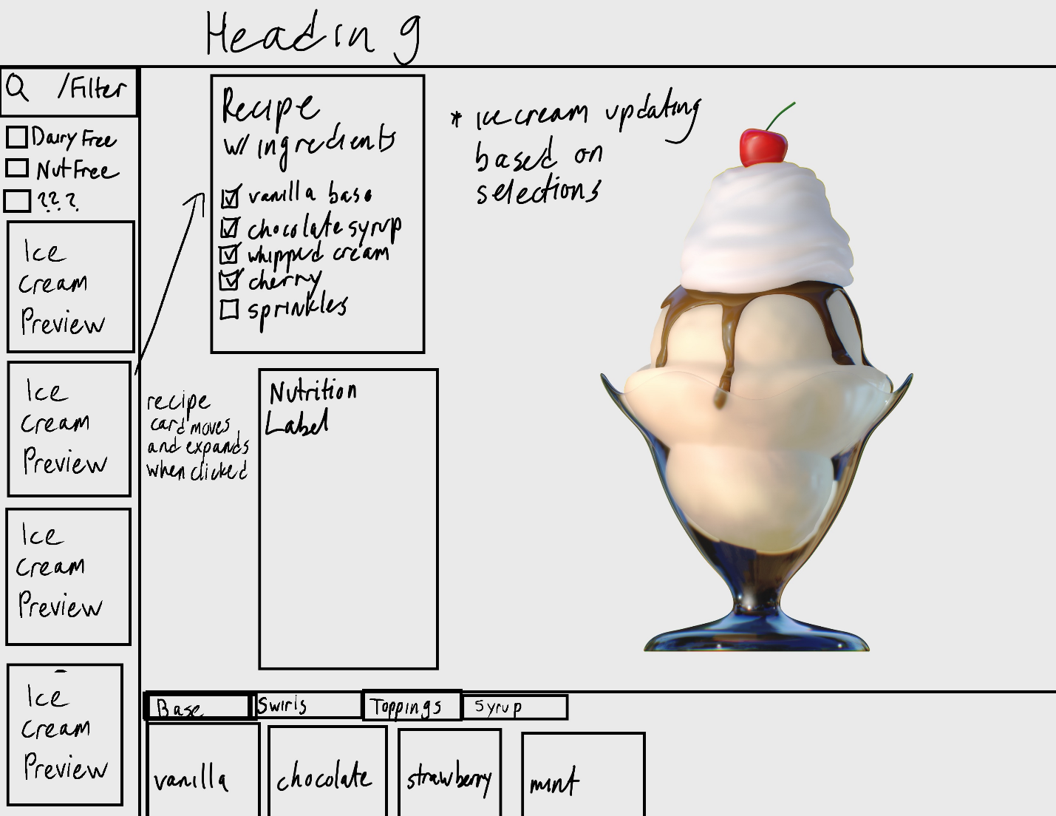
Homepage details (intro): Through this robust homepage, users will create their own ice cream recipe and be provided a visual reference.
Layouts:
- Heading:
  - Brand name and image
- Body
  - Filers: for allergens
  - Recipe tracking. Savable for future use
  - Quick select ice cream options: 2-3 shortlist of popular options.
  - Nutrition label
  - Real time ice cream visual
  - Selection list in box form for categories such as: Base, Swirl, Toppings, and Syrup.
    - Sublets for each selection item options.
Each Page Details: (Explain the detailed information about the topic)
DO WE HAVE MORE PAGES?
Functionality:
Transition implementation details:
Ice cream angle may rotate to see other side?
Transformations implementation details:
Should the topping fall on to the ice cream from above as they are added or just appear?
Animations implementation details:
User Experience: NOT SURE
Test Cases: UNSURE
Conduct usability testing with a focus group to gather feedback on navigation and user interaction. ?
Test the website's responsiveness on different devices and screen sizes. FOR LATER?
Approach to Refine Improvements:
Incorporate user feedback to optimize the user interface and streamline the user experience.
Iterate on design elements based on usability testing results to ensure intuitive navigation and clear
information presentation.
Explain - Proposed APIs if any:
Statement:
We, the undersigned members of the group, acknowledge that we understand the conditions
outlined in this proposal. We are committed to actively participating in the implementation of the
group project from start to finish. We understand that individual grades may vary based on our
contributions and performance, and we agree to present an important phase of the work
collectively.
Signed proposal:
Name: FN____________ ____________ LN ____________ ____________ [ ]
Name: FN____________ ____________ LN ____________ ____________ [ ]
Name: FN____________ ____________ LN ____________ ____________ [ ]
This proposal outlines our plan to develop an interactive website that leverages CSS to create
captivating user interfaces. We believe that this project aligns with the objectives of the web
development class and offers an opportunity to explore CSS transformations, transitions, and
animations in a practical setting. We are excited about the potential of this project and look
forward to bringing our ideas to life.

